Triangular Prism

Definition
# Source: AI Source: Provided by: [Data Path: Persons Table -> ID Column: 1, Name_En Column: Motasem Essam] -> From: [ChatGPT] on [7/25/2026]
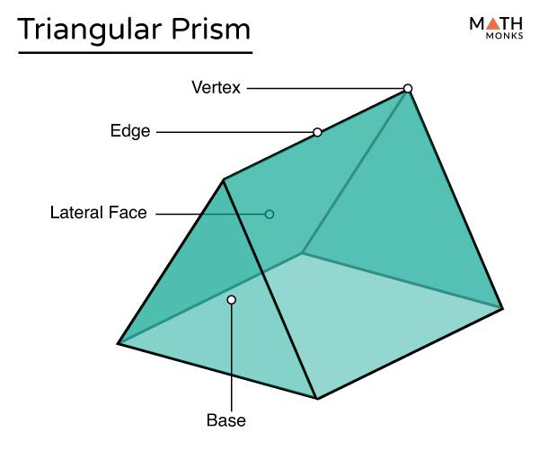
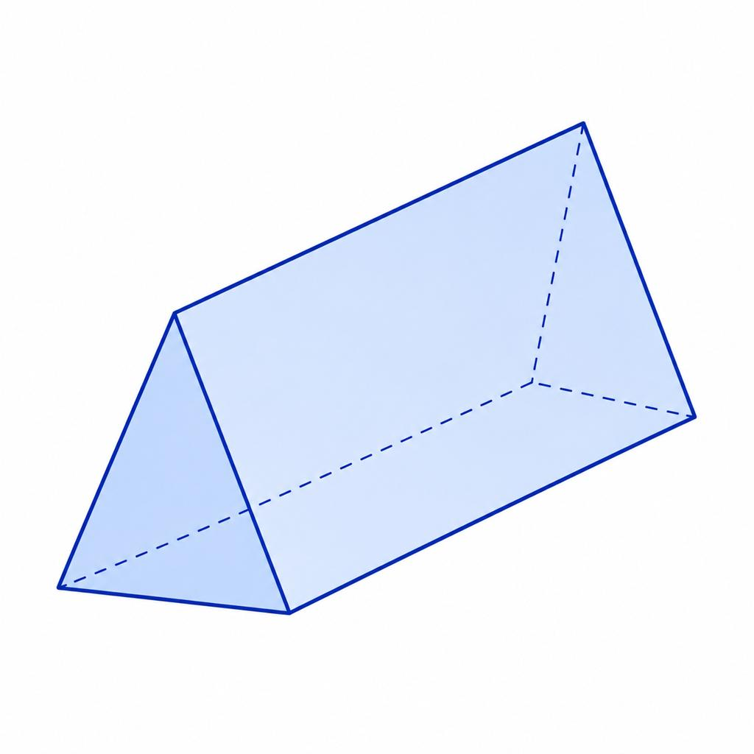
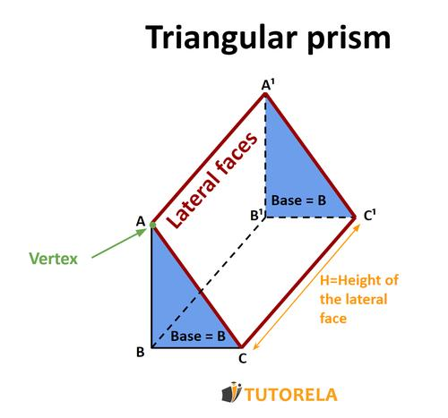
A triangular prism is a polyhedron with two congruent, parallel triangular bases connected by three lateral faces.
The two triangular bases have the same shape and size. Each vertex of one base corresponds to a vertex of the other base, and the corresponding vertices are connected by three lateral edges.
A triangular prism has:
- 2 triangular bases
- 3 lateral faces
- 5 faces in total
- 9 edges
- 6 vertices
For a right triangular prism, the lateral edges are perpendicular to the base planes, and the lateral faces are rectangles. For an oblique triangular prism, the lateral edges are inclined to the base planes, and the lateral faces are generally parallelograms.

Simple Definition
# Source: AI Source: Provided by: [Data Path: Persons Table -> ID Column: 1, Name_En Column: Motasem Essam] -> From: [ChatGPT] on [7/25/2026]
A triangular prism is a three-dimensional solid with two identical, parallel triangles joined by three side faces.
It resembles a triangle extended through a certain distance.

Classification Tree
# Source: AI Source: Provided by: [Data Path: Persons Table -> ID Column: 1, Name_En Column: Motasem Essam] -> From: [ChatGPT] on [7/25/2026]
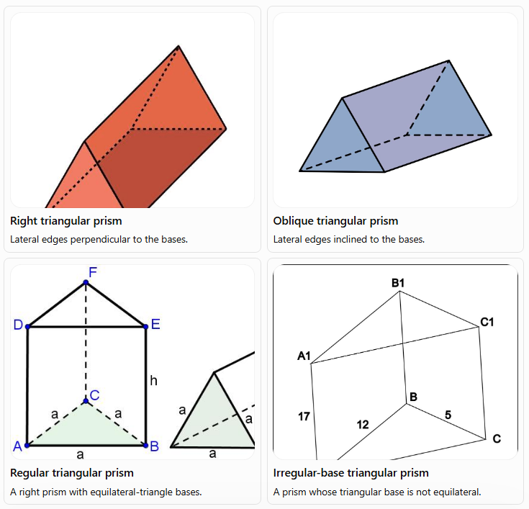
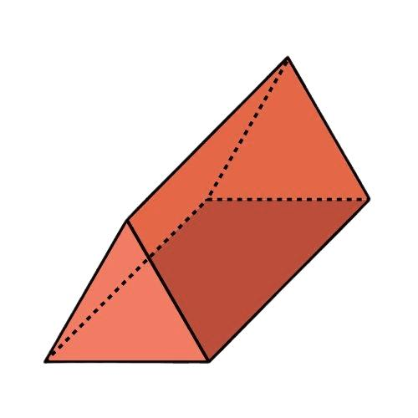
Right triangular prism
Lateral edges perpendicular to the bases.
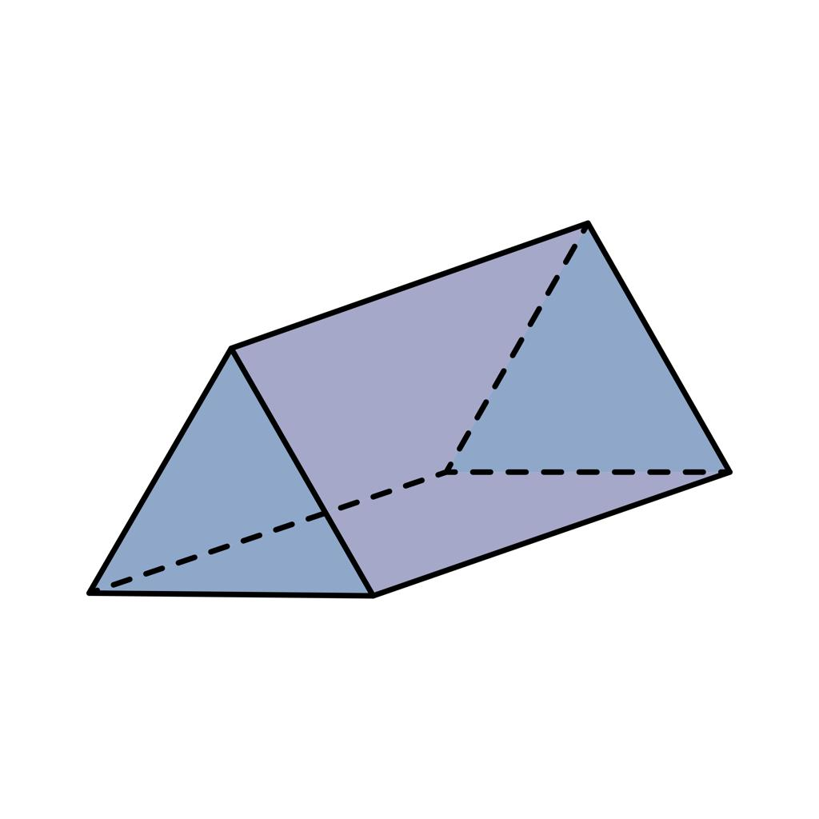
Oblique triangular prism
Lateral edges inclined to the bases.
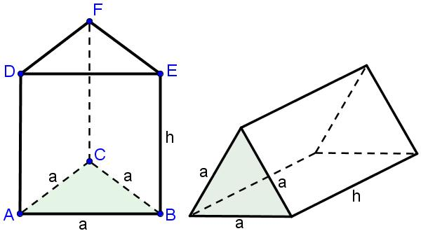
Regular triangular prism
A right prism with equilateral-triangle bases.
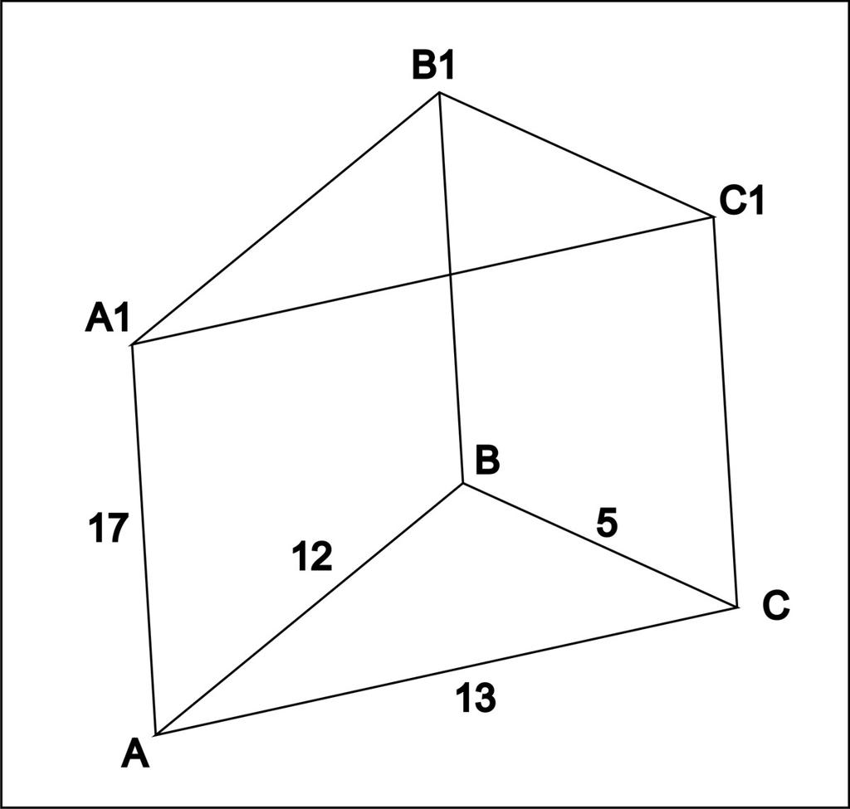
Irregular-base triangular prism
A prism whose triangular base is not equilateral.
Terminology note: In the standard classification, a regular prism has a regular polygonal base and is a right prism. Since a regular triangle is equilateral, a regular triangular prism has equilateral-triangle bases and rectangular lateral faces.

Parts of a Triangular Prism
# Source: AI Source: Provided by: [Data Path: Persons Table -> ID Column: 1, Name_En Column: Motasem Essam] -> From: [ChatGPT] on [7/25/2026]

A triangular prism consists of several geometric parts.
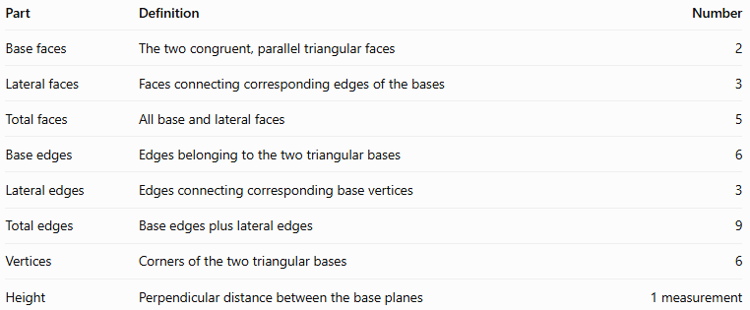
Part | Definition | Number
Base faces | The two congruent, parallel triangular faces | 2
Lateral faces | Faces connecting corresponding edges of the bases | 3
Total faces | All base and lateral faces | 5
Base edges | Edges belonging to the two triangular bases | 6
Lateral edges | Edges connecting corresponding base vertices | 3
Total edges | Base edges plus lateral edges | 9
Vertices | Corners of the two triangular bases | 6
Height | Perpendicular distance between the base planes | 1 measurement

1. Triangular bases
# Source: AI Source: Provided by: [Data Path: Persons Table -> ID Column: 1, Name_En Column: Motasem Essam] -> From: [ChatGPT] on [7/25/2026]
The bases are the two congruent triangles at opposite ends of the prism. Each base has three sides and three vertices.

2. Lateral faces
# Source: AI Source: Provided by: [Data Path: Persons Table -> ID Column: 1, Name_En Column: Motasem Essam] -> From: [ChatGPT] on [7/25/2026]
The three lateral faces connect the corresponding sides of the two triangular bases. In a right triangular prism, these faces are rectangles.

3. Lateral edges
# Source: AI Source: Provided by: [Data Path: Persons Table -> ID Column: 1, Name_En Column: Motasem Essam] -> From: [ChatGPT] on [7/25/2026]
The three lateral edges connect corresponding vertices of the bases. In a right prism, each lateral edge has length equal to the prism's height.

4. Height
# Source: AI Source: Provided by: [Data Path: Persons Table -> ID Column: 1, Name_En Column: Motasem Essam] -> From: [ChatGPT] on [7/25/2026]
The height is the perpendicular distance between the two base planes. It is not necessarily the length of a lateral edge in an oblique prism.

Mathematical Properties and Formulas
# Source: AI Source: Provided by: [Data Path: Persons Table -> ID Column: 1, Name_En Column: Motasem Essam] -> From: [ChatGPT] on [7/25/2026]
Let:
- $a,b,c$ = side lengths of the triangular base
- $B$ = area of the triangular base
- $p$ = perimeter of the triangular base
- $h$ = perpendicular height of the prism
- $A_{L}$ = lateral surface area
- $A_{T}$ = total surface area
- $V$ = volume

1. Number of faces, edges, and vertices
# Source: AI Source: Provided by: [Data Path: Persons Table -> ID Column: 1, Name_En Column: Motasem Essam] -> From: [ChatGPT] on [7/25/2026]
A triangular prism has a triangular base, so $n=3$.
For any $n$-gonal prism:
$$F=n+2, E=3n, V=2n$$
For a triangular prism:
$$F=3+2=\boxed{5}$$
$$E=3\left(3\right)=\boxed{9}$$
$$V=2\left(3\right)=\boxed{6}$$

2. Area of the triangular base
# Source: AI Source: Provided by: [Data Path: Persons Table -> ID Column: 1, Name_En Column: Motasem Essam] -> From: [ChatGPT] on [7/25/2026]
If the base triangle has base length $b$ and perpendicular triangle height $t$, then:
$$\boxed{B=\frac{12}{b}t}$$
If all three side lengths are known, Heron's formula can be used:
$$s=\frac{a+b+c}{2}$$
$$\boxed{B=\sqrt{s\left(s-a\right)\left(s-b\right)\left(s-c\right)}}$$
Here, $s$ is the semiperimeter of the triangle.

3. Volume
# Source: AI Source: Provided by: [Data Path: Persons Table -> ID Column: 1, Name_En Column: Motasem Essam] -> From: [ChatGPT] on [7/25/2026]
The volume of any triangular prism is:
$$\boxed{V=Bh}$$
Using the triangle's base and perpendicular height:
$$\boxed{V=\frac{12}{b}th}$$
The two heights have different roles: $t$ is the height of the triangular base, while $h$ is the distance between the prism's base planes.

4. Lateral surface area
# Source: AI Source: Provided by: [Data Path: Persons Table -> ID Column: 1, Name_En Column: Motasem Essam] -> From: [ChatGPT] on [7/25/2026]
For a right triangular prism, the lateral surface area equals the perimeter of the triangular base multiplied by the prism's height:
$$\boxed{A_{L}=ph}$$
Since $p=a+b+c$:
$$\boxed{A_{L}=\left(a+b+c\right)h}$$
For an oblique triangular prism, the lateral faces are generally parallelograms. Calculate the area of each lateral face using its own dimensions and add the three areas.

5. Total surface area
# Source: AI Source: Provided by: [Data Path: Persons Table -> ID Column: 1, Name_En Column: Motasem Essam] -> From: [ChatGPT] on [7/25/2026]
For a right triangular prism:
$$\boxed{A_{T}=ph+2B}$$
Equivalently:
$$\boxed{A_{T}=\left(a+b+c\right)h+2B}$$
The formula adds the three rectangular lateral faces and the two triangular bases.
For an oblique prism, use:
$$A_{T}=A_{L}+2B$$
where $A_{L}$ is the sum of the three actual lateral-face areas.

Worked Examples
# Source: AI Source: Provided by: [Data Path: Persons Table -> ID Column: 1, Name_En Column: Motasem Essam] -> From: [ChatGPT] on [7/25/2026]
Example 1: Counting faces, edges, and vertices
Problem: Find the number of faces, edges, and vertices of a triangular prism.
Solution:
The base has three sides, so $n=3$.
Faces:
$$F=n+2=3+2=\boxed{5}$$
Edges:
$$E=3n=3\left(3\right)=\boxed{9}$$
Vertices:
$$V=2n=2\left(3\right)=\boxed{6}$$
Answer: The triangular prism has 5 faces, 9 edges, and 6 vertices.
Example 2: Calculating volume
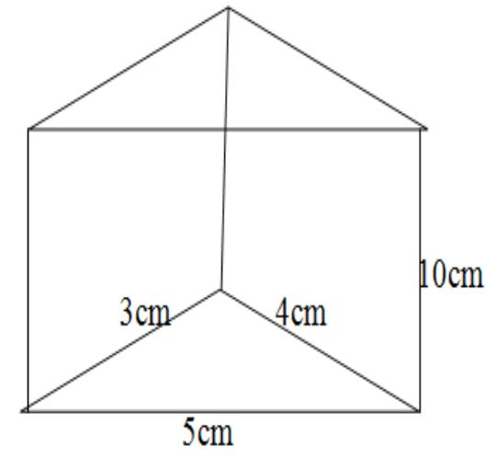
Problem: A right triangular prism has a right-triangle base with perpendicular sides of $3\text{ cm}$ and $4\text{ cm}$. The prism's height is $10\text{ cm}$. Find its volume.
Step 1: Calculate the base area.
$$B=\frac{12}{\left(3\right)}\left(4\right)=6{\text{ cm}}^{2}$$
Step 2: Calculate the volume.
$$V=Bh$$
$$V=6\left(10\right)$$
$$\boxed{V=60{\text{ cm}}^{3}}$$
Answer: The volume is $60{\text{ cm}}^{3}$.
Example 3: Calculating total surface area
Problem: A right triangular prism has a $3\text{ cm}$, $4\text{ cm}$, $5\text{ cm}$ right-triangle base and a prism height of $10\text{ cm}$. Find its total surface area.
Step 1: Calculate the base area.
$$B=\frac{12}{\left(3\right)}\left(4\right)=6{\text{ cm}}^{2}$$
Step 2: Calculate the base perimeter.
$$p=3+4+5=12\text{ cm}$$
Step 3: Calculate the lateral surface area.
$$A_{L}=ph=12\left(10\right)=120{\text{ cm}}^{2}$$
Step 4: Calculate the total surface area.
$$A_{T}=A_{L}+2B$$
$$A_{T}=120+2\left(6\right)$$
$$\boxed{A_{T}=132{\text{ cm}}^{2}}$$
Answer: The total surface area is $132{\text{ cm}}^{2}$.
Example 4: Finding the height from the volume
Problem: A triangular prism has a triangular base area of $18{\text{ cm}}^{2}$ and a volume of $144{\text{ cm}}^{3}$. Find the prism's height.
Start with:
$$V=Bh$$
Rearrange to find $h$:
$$h=\frac{V}{B}$$
Substitute the known values:
$$h=\frac{144}{18}$$
$$\boxed{h=8\text{ cm}}$$
Answer: The prism's perpendicular height is $8\text{ cm}$.

Euler's Formula for a Triangular Prism
# Source: AI Source: Provided by: [Data Path: Persons Table -> ID Column: 1, Name_En Column: Motasem Essam] -> From: [ChatGPT] on [7/25/2026]
A triangular prism is a convex polyhedron, so it satisfies Euler's formula:
$$\boxed{V-E+F=2}$$
Using its six vertices, nine edges, and five faces:
$$6-9+5=2$$
Therefore, the triangular prism satisfies Euler's formula.

Triangular Prism Compared with Related Solids
# Source: AI Source: Provided by: [Data Path: Persons Table -> ID Column: 1, Name_En Column: Motasem Essam] -> From: [ChatGPT] on [7/25/2026]
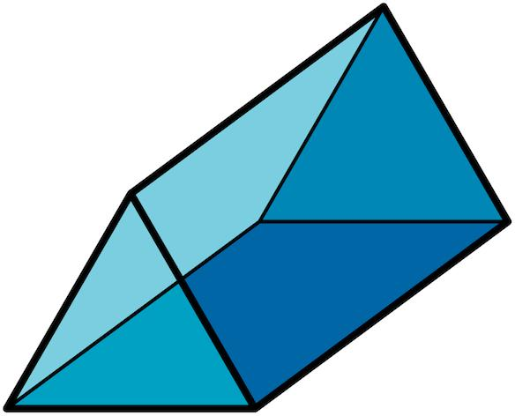
Triangular prism
Two triangular bases, three lateral faces, and a constant triangular cross-section along its length.
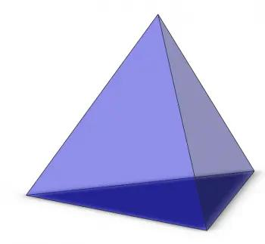
Triangular pyramid
One triangular base and three triangular lateral faces meeting at an apex. It has four faces, six edges, and four vertices.
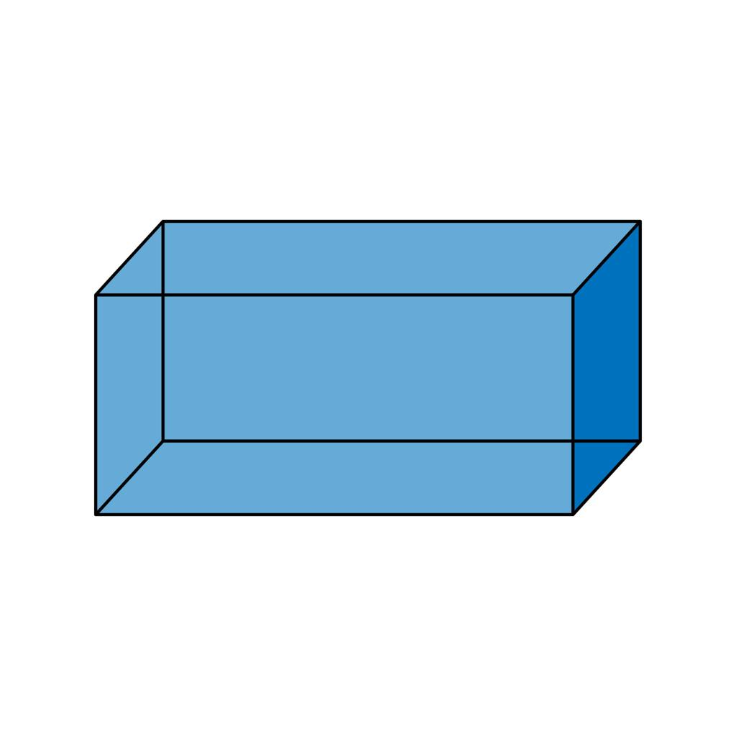
Rectangular prism
Two rectangular bases and four lateral faces in the standard prism description. It has six faces, twelve edges, and eight vertices.
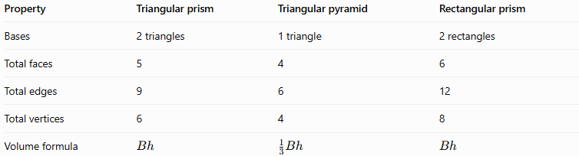
Property | Triangular prism | Triangular pyramid | Rectangular prism
Bases | 2 triangles | 1 triangle | 2 rectangles
Total faces | 5 | 4 | 6
Total edges | 9 | 6 | 12
Total vertices | 6 | 4 | 8
Volume formula | $$Bh$$ | $$\frac{1}{3}Bh$$ | $$Bh$$

Constructing Triangular Prism in Solid Geometry

Instruments Used
# Source: AI Source: Provided by: [Data Path: Persons Table -> ID Column: 1, Name_En Column: Motasem Essam] -> From: [ChatGPT] on [7/25/2026]
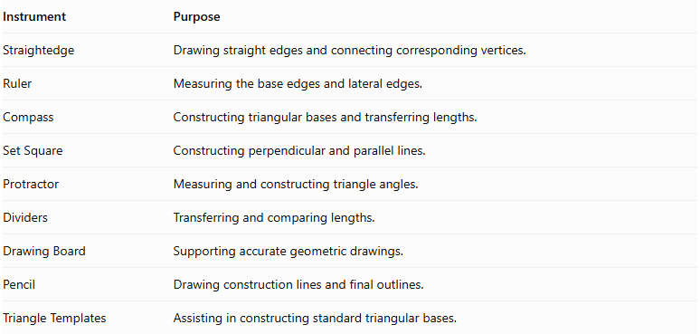
Instrument | Purpose
Straightedge | Drawing straight edges and connecting corresponding vertices.
Ruler | Measuring the base edges and lateral edges.
Compass | Constructing triangular bases and transferring lengths.
Set Square | Constructing perpendicular and parallel lines.
Protractor | Measuring and constructing triangle angles.
Dividers | Transferring and comparing lengths.
Drawing Board | Supporting accurate geometric drawings.
Pencil | Drawing construction lines and final outlines.
Triangle Templates | Assisting in constructing standard triangular bases.

Construction Procedures

Constructing a Right Triangular Prism
# Source: AI Source: Provided by: [Data Path: Persons Table -> ID Column: 1, Name_En Column: Motasem Essam] -> From: [ChatGPT] on [7/25/2026]
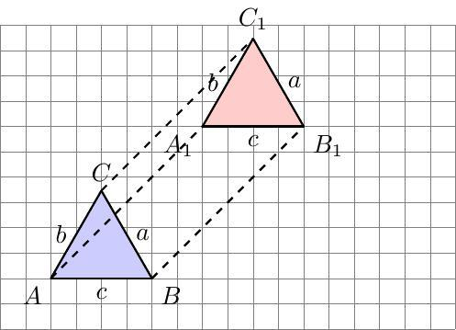
- Construct the first triangular base using a ruler, compass, or protractor.
- Determine the required perpendicular height of the prism.
- Construct a second congruent triangle parallel to the first triangle.
- Align the corresponding vertices along perpendicular lateral edges.
- Connect the corresponding vertices using straight lines.
- Complete the three lateral rectangular faces.
- Darken the visible edges and represent hidden edges with dashed lines when necessary.

Constructing an Oblique Triangular Prism
# Source: AI Source: Provided by: [Data Path: Persons Table -> ID Column: 1, Name_En Column: Motasem Essam] -> From: [ChatGPT] on [7/25/2026]
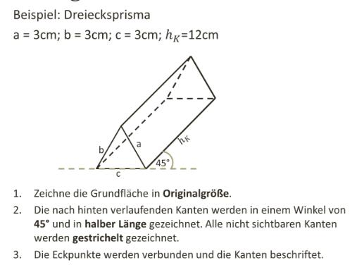
- Construct the first triangular base.
- Determine the required lateral-edge direction and length.
- Construct a second congruent triangular base in a parallel plane, displaced in the intended inclined direction.
- Connect corresponding vertices using parallel and equal lateral edges.
- Complete the three lateral parallelogram faces.
- Distinguish visible and hidden edges.

Constructing a Triangular Prism from a Net
# Source: AI Source: Provided by: [Data Path: Persons Table -> ID Column: 1, Name_En Column: Motasem Essam] -> From: [ChatGPT] on [7/25/2026]
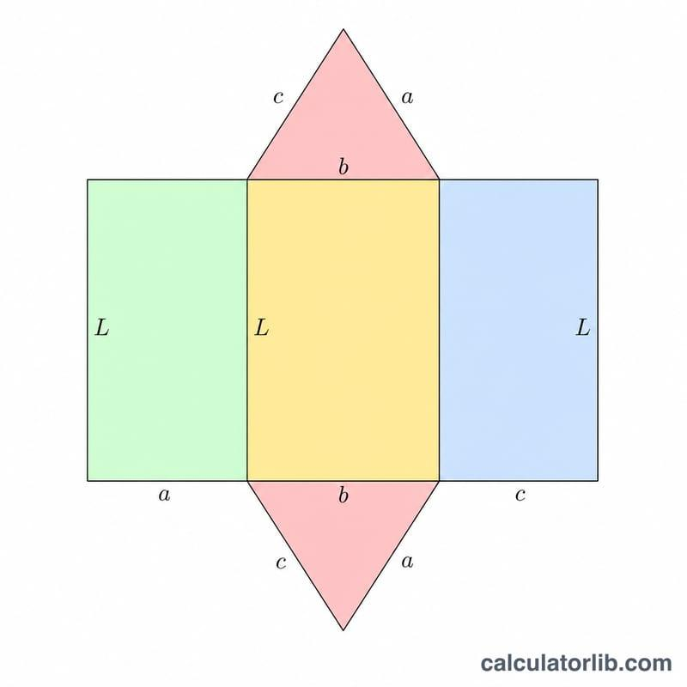
- Draw two congruent triangles.
- Construct three rectangles or parallelograms, depending on the intended prism.
- Attach each lateral face to its corresponding triangular base edge.
- Arrange the faces into a connected net.
- Cut out the net when constructing a physical model.
- Fold along the lateral edges.
- Join the corresponding boundary edges to form the triangular prism.

Constructing a Triangular Prism by Extrusion
# Source: AI Source: Provided by: [Data Path: Persons Table -> ID Column: 1, Name_En Column: Motasem Essam] -> From: [ChatGPT] on [7/25/2026]
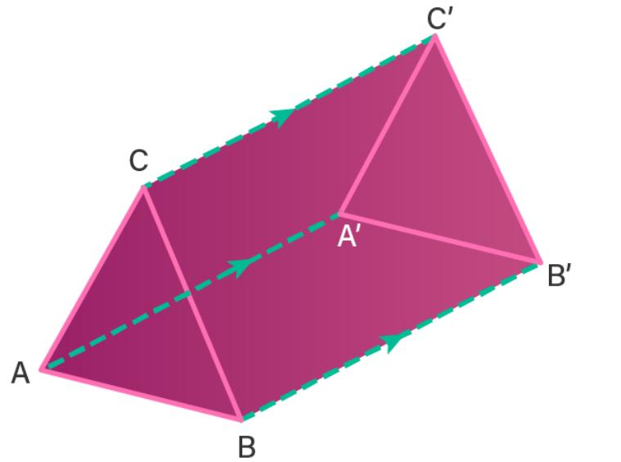
- Construct a triangular base.
- Establish the direction of translation.
- Transfer the triangle along that direction while preserving its shape and dimensions.
- Connect the three corresponding vertices.
- Complete the lateral faces.

Applications of Triangular Prisms
# Source: AI Source: Provided by: [Data Path: Persons Table -> ID Column: 1, Name_En Column: Motasem Essam] -> From: [ChatGPT] on [7/25/2026]
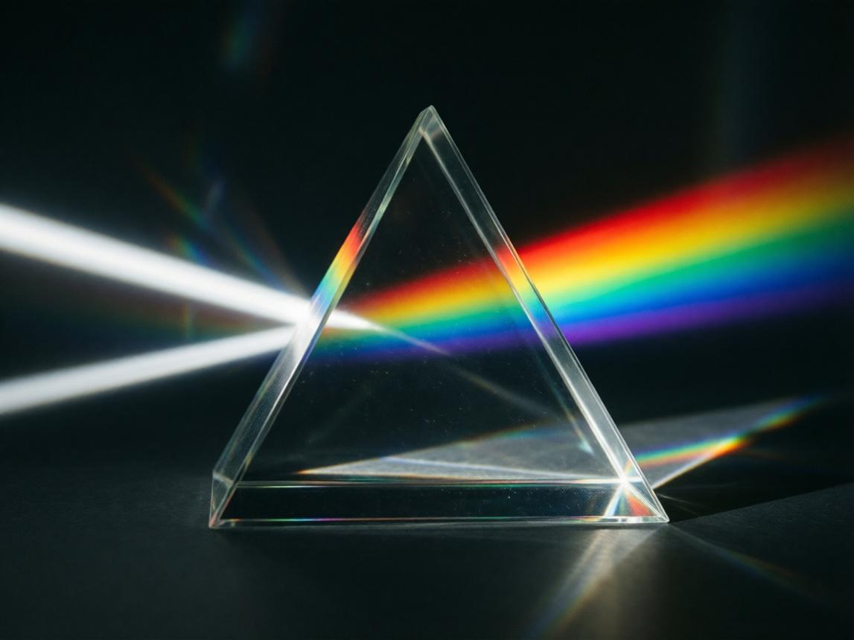

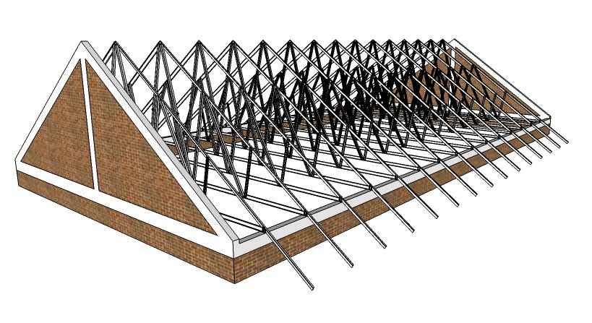
Triangular prisms are used in:
- Architecture: Roof structures and triangular-prism-shaped building sections.
- Packaging: Boxes and containers with triangular cross-sections.
- Optics: Glass prisms used to refract and disperse light.
- Engineering: Structural components and geometric models.
- Mathematics education: Teaching surface area, volume, and polyhedral properties.

Key Points
# Source: AI Source: Provided by: [Data Path: Persons Table -> ID Column: 1, Name_En Column: Motasem Essam] -> From: [ChatGPT] on [7/25/2026]
- A triangular prism has two congruent, parallel triangular bases.
- It has three lateral faces, five faces in total, nine edges, and six vertices.
- A right triangular prism has rectangular lateral faces.
- An oblique triangular prism has inclined lateral edges and generally parallelogram-shaped lateral faces.
- Its volume is $V=Bh$.
- For a right triangular prism, its lateral surface area is $A_{L}=ph$.
- Its total surface area is $A_{T}=ph+2B$ for a right prism.
- It satisfies Euler's formula: $V-E+F=2$.

Conclusion
# Source: AI Source: Provided by: [Data Path: Persons Table -> ID Column: 1, Name_En Column: Motasem Essam] -> From: [ChatGPT] on [7/25/2026]
A triangular prism is a polyhedron characterized by two congruent triangular bases joined by three lateral faces. It is an important example for learning how the geometry of a base determines the number of faces, edges, and vertices, and how base area and prism height determine volume.

